Chapter 7, Solution 50.

For the capacitor voltage,
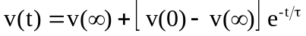
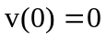

For t > 0, we transform the current source to a voltage source as shown in Fig. (a).
1 k
30 V
(a)
2 k

+
−
1 k
+
v
−
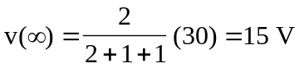
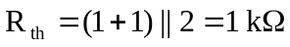
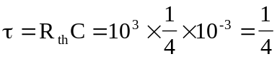
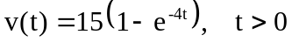

We now obtain 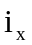 from v(t). Consider Fig. (b).
(b)
1 k
1 k
v
2 k
1/4 mF
30 mA
i_{x}
i_{T}
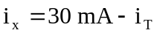
But 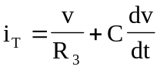
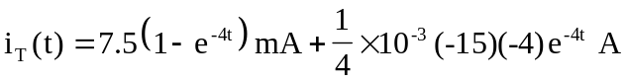
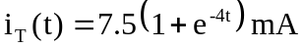

Thus,
